**Comprehensive Development Scheme**

**For**

**Port District No. 1 of Wahkiakum County, Washington**

**______________, 2024**

**Adopted by Port District No. 1 of Wahkiakum County Commission**

**on ___________, 2024 by Resolution No. 2024-___**

Table of Contents

Background and History of Port District No. 1 of Wahkiakum County 4

Creation of the Port 4

Early History of Port District #1 5

Elochoman Slough Marina Development 5

Other Services 7

Present Situation 8

2024 Comprehensive Scheme Process 9

Existing Conditions and Inventory of Facilities and Assets 10

Regulatory Controls 11

Shoreline Master Plan 12

Town of Cathlamet Comprehensive Plan 12

Wahkiakum County Comprehensive Plan Update 13

Current Port Land Use 13

Access, Parking and Circulation 15

Marina Area 15

Existing Utilities 16

Use Issues and Constraints 16

Mission, Goals and Objectives 17

Goals, Objectives, and Rationale 17

Elochoman Slough Marina Goals 17

Economic and Industrial Development Goals 18

Time Frames 19

Amending the Comprehensive Development Scheme 19

Demand and Needs Analysis 21

Marina Usage 21

Demographics 21

Demand and Need Summary 23

Economic Development and Industrial Development 23

Port 1 Role in Economic Development 24

Economic Development at the Marina 25

Economic Development Beyond the Marina 26

Capital Improvement Plan 27

Discussion of Capital Improvement Projects 28

Formal Adoption Process 30

Appendix A: Historical Goals, Objectives, and Policies 31

1978 Comprehensive Development Scheme 32

1994 Comprehensive Scheme 34

2006 Comprehensive Scheme 36

Conditions in 2016 38

Appendix B: Summary of Public Input 39

# Background and History of Port District No. 1 of Wahkiakum County

## Creation of the Port

In the 1950s, the founding Port Commissioners recognized the value of building a moorage basin for both the commercial fishing fleet and recreational users. Both the Town of Cathlamet and Wahkiakum County were supportive partners in putting together the initial lands required to construct the moorage basin and upland supporting infrastructure. Much of the initial property for Port 1 was donated by generous citizens who wanted a first class marina for the community. The citizens voted to create Port District No. 1 of Wahkiakum County (the “Port”) on November 4, 1958. The vote was 365 in favor and 109 opposed. The first commissioners were elected by write-in vote:

* Robert Bacon Commissioner District #1
* Lawrence Ronning Commissioner District #2
* Russell Irving Commissioner District #3

**Exhibit 1. Official Ballot for Creation of Port District No. 1, November 4, 1958**

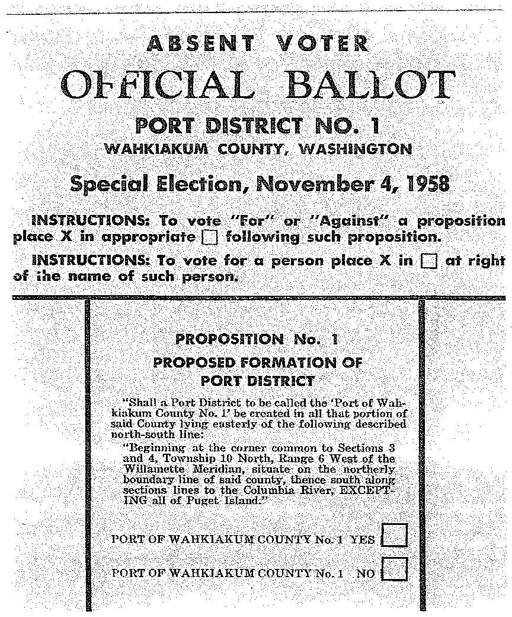

## Early History of Port District #1

The first meeting of the Port Commissioners was held on November 21, 1958. In the early years, the Port was focused almost entirely on acquiring lands and preparing for the creation of Elochoman Slough Marina. During this initial phase of land acquisitions, the Port began planning for the moorage basin and explored other economic opportunities. The adjacent rock quarry was donated by a citizen who recognized that the Port would need rock for the rip rap at the marina. The rock pit also quickly became a source of revenue for the Port.

## Elochoman Slough Marina Development

In November 1966, the Port Commissioners adopted a *Resolution of Form Assurances for Local Cooperation.* This document outlined the relationship, roles and responsibilities of the Port and U.S. Army Corps of Engineers in completing the necessary dredging and digging for the moorage basin. While it took several additional years of work, including multiple acquisitions of land and easements as well as many other studies and agreements, the Elochoman Slough moorage basin was finally dredged in 1970. In the following year, Port Commissioners worked with several state agencies to develop the marina’s initial infrastructure.

With an Interagency for Outdoor Recreation Grant, the Port constructed its first floats, ramps and other facilities in 1972. By June 1973, the commissioners were adopting the Rules and Regulations governing the use of Elochoman Slough Marina moorage basin, as well as establishing the initial fees. The Elochoman Slough Marina was an active place with both commercial and recreational users from its opening days and months. The photograph below, taken in 1985, shows an early configuration of docks, slips, and boathouses at the marina.

**Exhibit 2: Elochoman Slough Marina Circa 1985**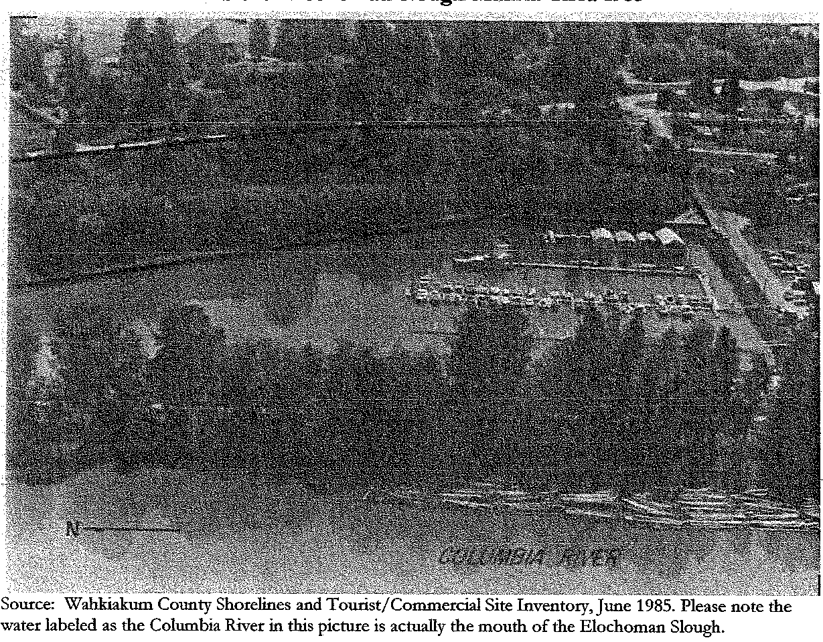

Throughout the 1970s, Port Commission meetings involved regular discussions of additional improvements and other amenities that the Port needed. Sometimes there were conflicts between the needs of commercial fishing fleet and the recreational users at the Port. Already the question of expanding the number of slips was on the table.

The Elochoman Slough Marina is a major asset for Wahkiakum County residents and visitors. The facility is located at River Mile 38 on the Columbia River at the East entrance of the Elochoman Slough, approximately 25 miles West of Longview, Washington. Boaters find safe harbor, moorage, fuel, and supplies at the Elochoman Marina. Fishermen use the marina as their port of call during the salmon fishing seasons. Visitors love the activity and relaxed atmosphere at the marina and during community events such as the Wooden Boat Festival, Bald Eagle Days, and the annual Salmon Derby.

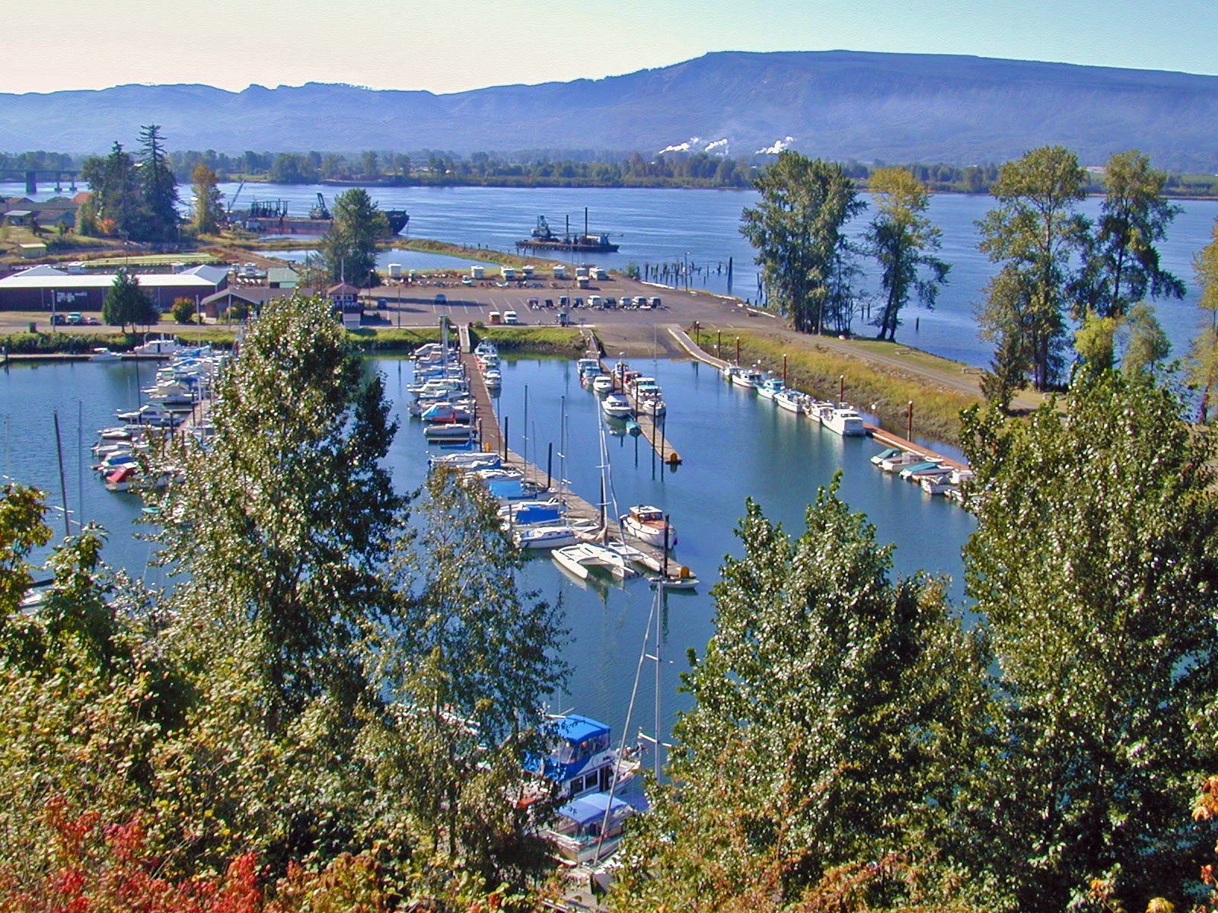

Photo by E. Erickson

From its inception, the Port has focused on building and maintaining a first-class marina that serves the needs of both commercial and recreational boats. To the present, major investments made by the Port are devoted to improving and expanding the marina and its capacity to serve the needs of the ~~boating~~ public.

## Other Services

The Port offers a variety of services aimed at supporting the local community and fostering economic growth.

**Commercial Leasing and Storage**: The Port offers industrial and commercial leasing opportunities, providing businesses with access to the waterfront, as well as storage unit facilities.

**Recreational Amenities**: In addition to moorage and the boat launch, the Port offers recreational vehicle stays, camping sites, cabin rentals, a Columbia River viewing deck, picnic sites and a communal barbecue and outdoor meeting area. These amenities offer residents and visitors opportunities for leisure and outdoor activities, enhancing the quality of life in the community.

## Present Situation

The Elochoman Slough Marina is focused on Wahkiakum County recreational and economic activity. Boaters from Portland, Vancouver, Ilwaco, Astoria, and other areas flock to the Elochoman Slough Marina because of its location, its historical river town amenities, and the pristine rural character of the surrounding land. Both commercial and recreational fishermen frequent the Elochoman Slough Marina, especially during salmon fishing windows in the spring and the fall. In addition, the Army Corps of Engineers and other entities utilize the marina when conducting operations in adjacent areas of the Columbia River.

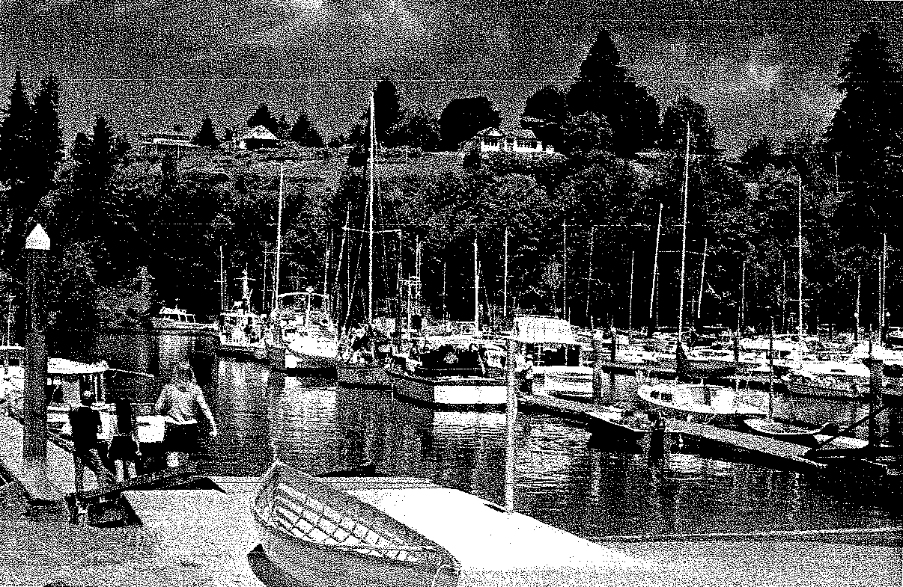

Photo by E.Erickson, Elochoman Slough Marina on a busy summer day.

The Port has made some key upgrades and additions to its facilities since 2016, and wishes to continue to contribute to the economic growth of Wahkiakum County and to update its comprehensive plan accordingly.

## 2024 Comprehensive Scheme Process

The updates in this Comprehensive Scheme build on the progress achieved by the Port. The new Comprehensive Scheme honors the strong commitment to providing a well-designed and maintained moorage facility for use by the residents of the County and the many visitors and tourists who come to the community. In addition, the update will continue and focus the earlier industrial and economic development goals articulated by the Port Commissioners in the 2016 Comprehensive Scheme. Finally, the update will identify new objectives and projects that will fulfill the goals of the Port.

The updated Comprehensive Scheme will also serve as a planning document for use with the Interagency for Outdoor Recreation and other federal and state agencies that might partner with the Port to expand its facilities. The general outline of the Comprehensive Scheme will include the following sections:

1. Background and History of the Port
2. Existing Conditions and Inventory of Facilities, Assets and Property
3. Mission, Goals and Objectives
4. Demand and Need Analysis
5. Capital Improvements Plan
6. Appendix A: Historical Goals, Objectives and Policies
7. Appendix B: Summary of Public Input

The process approved by the Port Commissioners for completing the update and expansion of the Comprehensive Scheme includes:

* Updating the Port’s inventory of facilities and assets
* Refining the Port’s mission, goals and objectives
* Researching the demand and need for facilities and services at the Port
* Developing a Capital Improvement Plan

Public input will be sought during a public meeting and through written submission. The object of taking public input is to:

* Gather input on the goals and objectives articulated by the Port Commissioners
* Identify additional needs that might be added to the list of projects
* Receive feedback on the Capital Improvement Plan

The entire Comprehensive Scheme will then be presented to the Port in a public hearing. The Port will refine and/or adopt the Comprehensive Scheme at the same or an additional public hearing.

## Existing Conditions and Inventory of Facilities and Assets

The Elochoman Slough Marina is the jewel of the Port and Cathlamet. It is an active marina with intense use by recreational fishing boats yachting clubs up and down the Columbia River, community members and the general public. Visitors come to the marina from all over Washington State and the Northwest. The location of the marina offers good shelter from both the wind and waves that are common along the lower Columbia River. In addition, visitors can enjoy the scenic beauty of the surrounding area and the charm of Cathlamet with its distinct river town character.

**Exhibit 3: Location of the Elochoman Slough Marina**

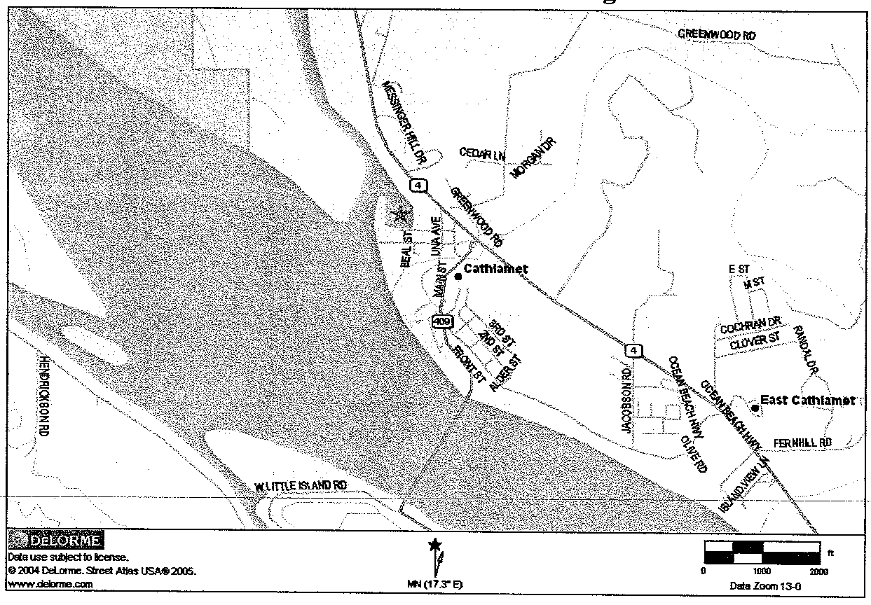

The Port property is located on the western edge of Cathlamet. The marina basin opens into the Elochoman Slough and is just about two hundred yards from the Columbia River. Boaters have ready access to prized fishing locations in and around Puget Island and along the Cathlamet Channel. The marina is in a prime location for afternoon summer sailing, kayaking, rowing and other human-powered boating activities. See Exhibit 4 for more detail on the location of the marina.

**Exhibit 4: Geographic Location of Cathlamet and the Elochoman Slough Marina**

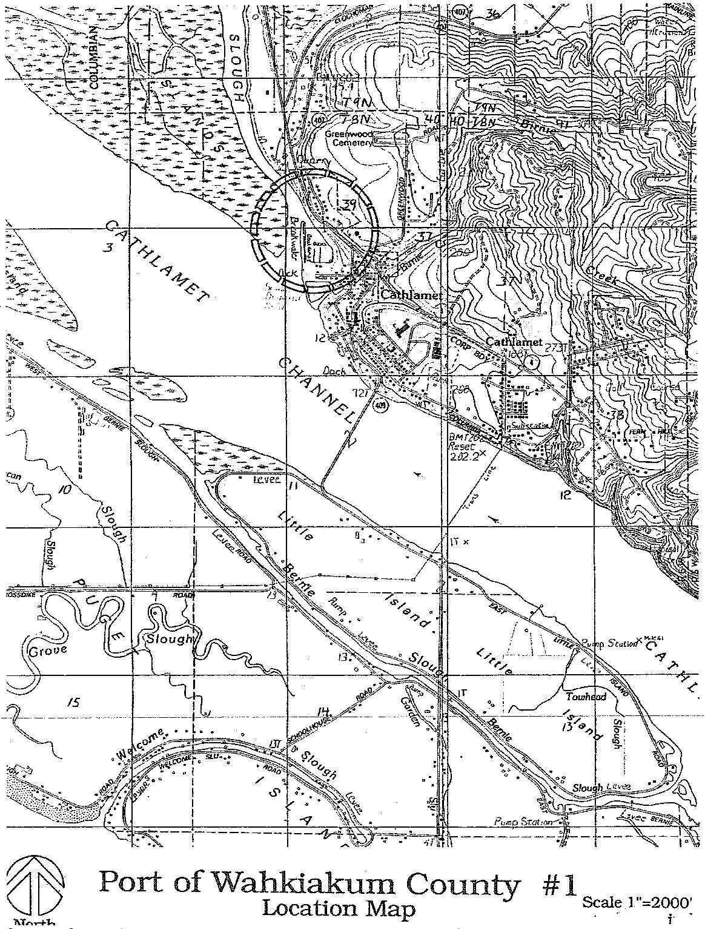

Source: Comprehensive Development Scheme for the Port of Wahkiakum County No. 1, The Benkendorf Associates Corporation, 1994.

In addition to the marina, the Port operates a storage facility, an office space, a covered picnic area with barbecue, overnight cabin, RV and camping areas, and leases space to business enterprises.

## Regulatory Controls

Port property ownership includes approximately 25 acres of land surrounding the Elochoman Marina. All of the property under Port ownership is within the Town of Cathlamet municipal boundary. The land is zoned Commercial/Industrial District. This zoning designation allows a high degree of flexibility in the types of activities allowed.

**Exhibit 5: Port 1 Aerial Photo**

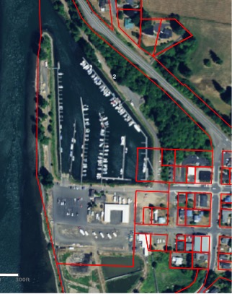

Note: Aerial photo taken from Wahkiakum County GIS mapping program.

The land along the waterfront is presently a parking area and location where campers and RVs can stay overnight. This area is within the 100 year flood boundary.

## Shoreline Master Plan

Port property is classified as Urban within the Wahkiakum County and Town of Cathlamet Shoreline Management Master Program, Revised in 2023. The Shoreline Master Program defines the regulations which control development of state shorelines and is managed by the Washington State Department of Natural Resources. The Columbia underwater lands in front of Port property are also managed by the Department of Natural Resources. The Urban classification is flexible, yet it does define regulations which specifically pertain to construction and operations, marina development, and recreation development.

## Town of Cathlamet Comprehensive Plan

The Town of Cathlamet updated its Comprehensive Plan in 2002*.* The Town discusses the importance of continued cooperation with the Port both in maintaining the marina and in expanding facilities for the community. As of 2024, the Town’s Comprehensive Plan is being updated. The Port plans to continue to work together with the Town to identify mutually consistent goals and objectives.

## Wahkiakum County Comprehensive Plan Update

Wahkiakum County is currently updating its County Comprehensive Plan. The latest draft prepared in June 2006 and edited by the County Commissioners in August 2008, focuses a section in its Economic Development Summary on the Riverine Economy, noting the declines in the fishing industry along with the increases in tourism and recreational boating.

The Comprehensive Plan recommends the following:

* Use land use and public policy tools that encourage shoreline industry in support of commercial fishing, e.g., zoning, shoreline management, tax exemptions and deferrals, direct sales, etc.
* Promote value-added fish and riverine products and activities.
* Support efforts to provide facilities and services needed to assist value-added enterprises, such as “Skamokawa Harbor” development.
* Encourage the formation of a “community food system” and include value-added fish products, linking producers to community institutions, businesses, and households.

In another section of the County Comprehensive Plan, the marina’s value in attracting and supporting tourists and visitors is highlighted. The County Comprehensive Plan is compatible with the current goals and objectives of the Port.

In developing the 2024 Comprehensive Scheme, the Port has considered and coordinated its development goals and objectives with these other planning and strategic documents. The Port Commissioners intend to remain engaged with key community planning processes that could support or constrain the Port in its future development.

## Current Port Land Use

The current Port property is primarily devoted to the Elochoman Marina and supporting uses associated with the marina. There is a viewing deck along the river’s edge, parking and boat/trailer parking areas, a large storage building with rental storage units, open boat and boat trailer storage areas, restroom / shower facilities, covered picnic area, dry land camping, laundry facilities, a marina office, yurts, park models, cabins, RV spaces with hook-ups, a food vendor, a commercial building currently housing a brewery tenant, a restaurant, fuel station and two sewage dump stations.

In 2005, the Port moved the boat and trailer storage area and constructed a 15-space Recreational Vehicle (RV) park with state-of-the-art hook-ups (i.e., water, power, wireless on the northwestern edge of its property to provide overnight accommodations for visitors. In 2022, the Port constructed 7 additional Recreational Vehicle (RV) parking sites along the Riverview with state-of-the-art hook-ups. These accommodations were designed to meet the Port’s goals of enhancing the overnight facilities and continuing to fill a need for simple, utilitarian overnight lodging not offered elsewhere in the county.

In 2014, the Port added a commercial building that was leased to a tenant that is currently operating a brewery. In 2019, the tenant leased additional land closer to the waterfront and constructed a new taphouse and restaurant.

**Exhibit 6: Port 1 in 2024**



Note: The aerial photo reflects the RV spaces, park models and commercial building. Photo taken from Wahkiakum County GIS mapping program.

## Access, Parking and Circulation

From State Route 4, the primary access to the Port is via 3rd and 2nd Streets. Directional and road signage on the Port grounds was upgraded in 2022. A secondary road is now the location of boat and trailer storage, as well as providing access to the rock pit.

Pedestrian access to the marina is available both on a paved path that runs along the river front side of the sewerage lagoons and via a wooden foot bridge from Strong Park to the marina.

The boat trailer parking area allows for approximately 30 boat trailer parking spaces with an additional area for overflow. Additional boat trailer parking with a shuttle service may be desirable in the future.

## Marina Area

The Port has initiated a program of dock replacement that will eventually upgrade all the docks in the marina. As of 2023, the Port has replaced approximately 200 feet of dock, and 18 fingers on C-dock. The Port has selected modern, environmentally-friendly materials for piers, docks, ramps, and other in-water installations. Of the approximately 330 slips available in the marina, 125 are available for transient moorage, with 25 new slips capable of accommodating vessels of 26 feet or longer.

Due to the natural flushing action of the tides at this point along the River, the moorage basin and access way generally require annual maintenance dredging. Port 1 and Port 2 cooperatively arranged for channel dredging in 2004. Since that time, the Port has purchased a dredge and support equipment, and is able to dredge the entrance to the marina and deposit the dredge spoils on neighboring property owned by the Town of Cathlamet and the Port. The marina and its entrance were dredged in 2017 and 2018. The Port is studying additional options for future dredging needs.

The boat launch was repaired in 2005 to fill in a scour hole that had developed at the edge of the concrete ramp. This improvement makes launching easier and safer in extremely low tides. In 2016, the Port developed a policy to discourage boat loading activity that creates this type of damage.

The Port continues to work with vendors to provide beverages and food items, and is looking to lease space for food carts and other vendors. The Port currently operates the Elochoman Marina Street Market in the spring and summer seasons, attracting residents and visitors with a variety of local vendors and entertainers.

The Port’s sewer system was upgraded in 2022 with replacement of pumps and all plumbing as well as addition of a second pump.

## Existing Utilities

Power is provided by Public Utility District No. 1 of Wahkiakum County and is available throughout the marina area. The primary power lines are underground with service lines connecting to light poles and structures overhead. As the Port repairs and replaces docks and piers, overhead power is relocated and encased under the piers, eliminating overhead service lines.

From 2022 through 2024, the Port installed power and water lines to all of the Dike and Wesley camping sites.

Water is provided by Town water lines which run underground along 2nd and 3rd Streets. The line under 2nd Street connects to the Port office. The 3rd Street line runs out along the dike to the fuel dock area.

Wastewater treatment trunk lines are located underground along 3rd Street from Una Street to the Beal Street easement, along the Beal Street easement to the wastewater treatment facilities adjacent to the sewer lagoons. A service line connects into this trunk line from the port restroom facilities and marina from 3rd Street.

Internet services are available through a Town-wide, free, wireless system. Visitors in the marina, the RV park and in the Park Models are able to access the internet by logging on to the wireless provider.

## Use Issues and Constraints

**Soil and Ground Conditions**

The Port has completed several geological and engineering studies in the past. These analyses examined the soils and condition along the Northwestern edge of the Port property and under the Port parking area. In all cases, the studies identified significant issues that make the construction of large buildings on these soils more challenging. The nature of the soils and their composition may require piling systems and other specialized foundation features to provide the support necessary for large structures.

**Marina Slip Demand**

In spite of continuing efforts to increase the number of slips, there is still a waiting list for moorage at the marina. Expansion potential within the current basin is very limited due to the physical constraints of the water area. The Port is actively evaluating options for creating additional slips and transient moorage. Please see Demand and Need Analysis which follows.

Neither the soil conditions nor the current limitations on expansion space are serious impediments to the Port’s goals and objectives. The Port is working closely with community leaders and planners to identify the best methods for expanding moorage at the marina. In addition, the Port is prepared to work with community leaders and interested investors to acquire property for additional economic development activities.

# Mission, Goals and Objectives

The mission of the Port was created in 1994 and continues to reflect the Port’s overall direction and values. With a small amendment to the 1994 mission statement, the Port’s mission is as follows:

**Port District Number 1 of Wahkiakum County is dedicated to the enhancement and diversification of the local economy as a means of improving the standard of living, business climate, and quality of services available to the citizens of and visitors to Wahkiakum County.**

The Port’s primary business function is the operation of its marina and the facilities that support the marina’s visitors and users. In addition, the Port will continue to seek opportunities to provide both land and infrastructure that will attract private sector investment and business organizations. In these two functions, the Port will support the growth of both tourism and business that has a direct and indirect multiplier effect on employment and wealth in Wahkiakum County. The Port itself benefits from economic growth throughout the region and will remain engaged in meeting the needs of the region for industrial, tourism and economic development property and the associated infrastructure.

## Goals, Objectives, and Rationale

The Port’s goals and values have not changed substantially from those of the earlier Comprehensive Schemes. The goals presented below are grounded in the Port 1’s history and continue the focus of prior Comprehensive Scheme goals.

## Elochoman Slough Marina Goals

***Maintain and expand a first class marina facility that attracts visitors and boaters to the Port and the community.***

**Objectives:**

1. Utilize the existing Port property to continue serving the needs of the marina.
2. Maintain, upgrade and expand marina facilities using state-of-the-art materials that minimize environmental impacts while improving the safety of the Port for its residents, visitors, and boaters.
3. Retain the architectural vernacular of the Port and the surrounding Town of Cathlamet in new buildings, landscaping, and other physical features of the Elochoman Slough Marina.
4. Continue to work cooperatively with County and Town organizations that promote tourism in Wahkiakum County.

**Rationale**: As recognized by the founding members of the Port Commission, providing a moorage basin and boating support facilities is a highly prized asset in Wahkiakum County. Both public and private sector stakeholders have articulated the value of the Elochoman Slough Marina as the location of major importance to the community. The Marina both serves the residents of Wahkiakum County and the many visitors that come here from the Pacific Northwest and beyond. The Marina is the focus of festivals and events that provide visitors and the community pleasurable activities and generate business activity throughout the county. The Marina remains the Port’s principal business focus.

***Improve the marine and boater experience by maintaining and expanding public access to the Columbia River for the local and visiting public.***

**Objectives**:

1. Continue to identify and provide improved parking for visitors and boaters with trailers using the marina.
2. Evaluate the feasibility of developing a new pier/gangway/dock and increase moorage for visitors to the marina.
3. Work with the Town of Cathlamet Downtown Revitalization effort.
4. Develop facilities for hand launching non-motorized boats such as kayaks, canoes, etc.

**Rationale**: The Elochoman Slough Marina is one of the best, most-sheltered, full service marinas on the Lower Columbia River. Providing visitors with boats on trailers access to the marina and the Columbia River attracts both the fishing and recreating public to the community. During key sport fishing seasons, the marina is a major point of departure for boaters fishing in the Lower Columbia. Boaters and yachting clubs from Portland to Astoria, and Skamania to Ilwaco, enjoy making the Elochoman Slough Marina a regular port of call. The nearby access to downtown Cathlamet, the many community festivals and events, and businesses, restaurants and bars are all enjoyed by boaters visiting the marina.

## Economic and Industrial Development Goals

***Expand economic activity in Wahkiakum County and the region by investing in land and infrastructure that will attract new wealth and employment to the community.***

**Objectives**:

1. Seek appropriate opportunities to acquire lands that can be developed for use as industrial and economic development sites.
2. In collaboration with federal, state and local partners, install the necessary infrastructure, including but not limited to, power, water, wastewater and roads, on Port owned properties.
3. Actively engage with appropriate state and local partners in business recruitment, seeking investment in light industry and economic activities that are clean and environmentally responsible.
4. Provide continuing property management for industrial properties that will meet the needs of businesses and organizations leasing Port lands and retain those businesses for the long-term.

**Rationale**: Ports have unique abilities to take the long view in terms of economic and industrial development. This means that Ports can acquire land that has potential value in the future for economic and industrial activity, invest in the public infrastructure that will attract new business activity, and actively recruit new business investment to the area. In establishing these abilities for Ports, the Legislature saw the Ports as economic engines for their communities and locations where commerce would be conducted. Port 1 stakeholders acknowledge that this is an important role for Port 1 and support collaborative work with the county, town and other organizations to attract new private sector investment to our community.

***Ensure that Port 1 investments in marketing and community relations activities support the achievement of Port 1 goals.***

**Objectives**:

1. Invest in the community organizations and activities that promote tourism and economic growth in the community.
2. Participate as members of organizations that conduct activities that impact the Port and its activities.

**Rationale**: Port 1 makes investments in marketing campaigns and community organizations designed to promote business and local economy. Port 1 values the support of these organizations in helping the Port achieve its goals and will continue to make investments in these organizations and activities so long as the support is continued.

## Time Frames

These goals and objectives are designed to guide the Port during the next 6 to 10 years. In addition, these goals and objectives are designed to help the Port evaluate emergent opportunities such as those that will occur as the Town of Cathlamet proceeds with development of adjacent ~~sewer lagoon~~ property. When carrying out a major project that is associated with the Port’s goals and objectives, the Port will conduct the appropriate public input sessions and take into account the desires of the community in implementing projects. Routine matters, such as the repair and replacement of docks or other maintenance of Port facilities are always discussed at the Port’s monthly Board of Commissioners meetings that are open, public meetings.

## Amending the Comprehensive Development Scheme

A Comprehensive Development Scheme is a conceptual plan, designed to lay out a port’s assets, proposed land uses and implementation plan. It is **not**, however, a specific commitment to a specific design feature, nor does it contain construction documents or project specific spending plans. The Comprehensive Scheme will give the public a big picture idea of what Port 1 intends to accomplish, as well as indicating some areas being explored. The Comprehensive Scheme can be amended by Port 1 in the same process that used to update and expand this planning document. Therefore, the intention to amend the Comprehensive Scheme is announced publicly, amendments are offered and discussed at a public hearing, and the amendments are reviewed and adopted during a Port Commission meeting that is open to the public.

If future developments in the Town of Cathlamet or Wahkiakum County warrant amending the Comprehensive Scheme, the Port Commission will make sure there is adequate public notice and opportunity to comment.

# Demand and Needs Analysis

## Marina Usage

The Elochoman Slough Marina is the only marina in Wahkiakum County. There are private moorages associated with homes on the sloughs of Puget Island and associated with the Skamokawa River and its sloughs (Brooks Slough and Steamboat Slough). However, the only location offering permanent and transient moorage in the county is the Elochoman Marina. There are approximately 250 permanent slips and 125 transient slips in the marina.

During the summer months, especially on holiday weekends, the marina is completely filled, with more than 300 boats tightly packed into the available space. During normal weekends, the number of slips in use average about 310, from March to September. In the winter months, the average number of slips in use is 250. There is a waiting list for permanent moorage, as many local fisherman and recreational boaters would like permanent moorage at the marina.

The Marina also provides RV spaces, dry camping, and lodging in park model units and yurts.

The Elochoman Marina is the only full service marina on the portion of the Columbia between the Port of Chinook and Longview. That is, the Elochoman Marina offers not only moorage, but a fuel dock, sewage pump out station, showers and laundry facilities. In addition, boaters can easily access downtown Cathlamet, with its stores and restaurants.

Many people relocating to or visiting Wahkiakum County are retired and have strong interests in outdoor recreation, including accessing the Columbia for boating and fishing.

## Demographics

Wahkiakum County is located directly on the Lower Columbia River in Southwest Washington. The Lower Columbia River is generally considered the portion of the river from the first major dam across the Columbia – the Bonneville Dam at Dallesport, Oregon. Visitors to the county and the Elochoman Marina come from primarily the counties along the Lower Columbia. We estimate that approximately 80 percent of the users of Elochoman Marina and its facilities come from the counties presented in Table 1 below.

**Table 1. Populations of Counties on the Lower Columbia River**

|  |  |
| --- | --- |
| ***County*** | ***2024 Population Estimate (WA)***  ***2022 Population Estimate (OR)*** |
| **WASHINGTON STATE** | |
| Clark | 536,300 |
| Cowlitz | 113,900 |
| Grays Harbor | 77,400 |
| Lewis | 84,950 |
| Pacific | 23,950 |
| Skamania | 12,075 |
| Wahkiakum | 4,550 |
|  |  |
| **OREGON COUNTIES** | |
| Clackamas | 425,316 |
| Clatsop | 41,428 |
| Columbia | 53,014 |
| Hood River | 23,888 |
| Multnomah | 820,672 |
| Washington | 605,036 |

*https://ofm.wa.gov/sites/default/files/public/dataresearch/pop/april1/ofm_april1_population_final.pdf*

*https://sos.oregon.gov/blue-book/Pages/local/county-population.aspx*

The population along the Lower Columbia River has been growing in recent years, with the strongest growth in Clark County, Washington and Clatsop County in Oregon. Visitors to Wahkiakum County are most often from Oregon and Washington.

The Elochoman Marina visitor data is presented in the table which follows:

**Table 2: 2023 Boaters and Visitors to Elochoman Marina**

|  |  |  |  |
| --- | --- | --- | --- |
| **County of Origin** | **State** | **Moorage** | **Total** |
| Wahkiakum County | WA | 131 | 212 |
| Cowlitz County | WA | 41 | 208 |
| Pacific County | WA | 17 | 36 |
| Other Washington Counties | WA | 311 | 937 |
| Oregon | OR | 77 | 297 |
| Other States | -- | 20 | 144 |
|  |  |  |  |
| Total Transactions | -- | 597 | 1834 |

Note: Data developed from Elochoman Marina MarinaWare™ database and includes all transactions.

The Port’s transactions are recorded by the MarinaWare™ software. From its installation in March 2005 through August 1st, 2024, 76% of the users of Port 1 are from Washington State, with 16% from Oregon, and the remaining 8% from other states. When examining only moorage transactions, the percentages are 83% from Washington, 13% from Oregon, and 4% are from other states.

Commercial fishing in Wahkiakum County and along the Columbia River in general has been declining over recent years. This is largely due to restrictions on fishing caused by the listing of several salmon species as threatened or endangered. In addition, court decisions requiring sharing of allocations with Native American fisherman have reduced the total number of fish available to commercial fisherman. The reduced availability of fish and the conflicts between commercial and recreational fishing will likely continue to decrease the total number of commercial boats in the county.

At the same time commercial fishing has been decreasing, recreational fishing has been increasing.

Expansion planning should take the trends in boat length, depth, width and height into account when constructing new docks, piers, and slips. In addition, the ratio of slips and moorage for boats less than 30 feet long and greater than 30 feet long should probably change as the Port plans construction and rearranges use of slips.

## Demand and Need Summary

Growth in the population in the Southwest Washington region makes the demand for more varied recreational facilities higher along with Lower Columbia River. In the case of Wahkiakum County, there is a continuing growth in boating and demand for more moorage at the marina. In fact, the growth in recreational boating in Wahkiakum County is the highest in our region. As is true elsewhere, there is a need for more moorage to accommodate additional draft vessels. Port 1 remains committed to the development of the marina and its associated facilities. Adding amenities that serve the boating public will also receive Port 1 attention.

# Economic Development and Industrial Development

Wahkiakum County, like many other rural counties with a high dependence on the extraction of natural resources, has been experiencing a period of economic adjustment and restructuring. In the past, Wahkiakum County was home to a robust and vital timber and fishing industry with extensive timber harvest, milling, fish processing and boat building. Agriculture was widespread and successful throughout the county. The height of this industrial period ended in the 1950s and has been declining ever since. Additional environmental and land use pressures have further reduced the economic activity associated with timber, fishing and agriculture, leading to the economic dislocations of the 1980s and the economic restructuring that is still unfolding today.

While Wahkiakum County still enjoys a healthy timber harvest sector, the county has under performed in other manufacturing sectors when compared to the state or nation. County leaders and planning officials all recognize the importance of growing small, clean manufacturing in the county if possible. There are a variety of strategies that may be explored however there is a lack of property that is ready to accommodate a manufacturing company.

The reasons for seeking clean, light manufacturing or other economic activity for the county is the need to maintain and increase the number of family wage jobs. Family wage jobs are the glue that holds communities together, ensuring that there are adequate numbers of kids to keep the schools open and vital, as well as providing the income that is spent in the businesses in the community.

Trends in the growth of the retirement age population and reductions in jobs of young families mean that generating new job creation activities are critical to maintain the county’s businesses, schools, and public facilities.

Also important in the creation of jobs and community development is the promotion of tourism and tourism-related activities.

## Port 1 Role in Economic Development

Port 1 is in the position to directly improve the economic well being of the county in several ways. The first, and most important, is maintaining and expanding the Elochoman Marina, its amenities, and adding boating related businesses. Second, and of increasing importance, is to join with the County, Town, Cowlitz-Wahkiakum Council of Governments and the Southwest Washington Economic Development District in securing the existing or new industrial lands and making infrastructure improvements to those properties that will attract new business to the area. New businesses that are in keeping with the rural character of our community will also create jobs for young families, supporting the schools and local businesses, and help the county experience increasing wealth. Third, is to promote tourism and to organize or collaborate with other entities to conduct tourism-related activities in order to encourage people to make Wahkiakum County a travel destination.

## Economic Development at the Marina

Aside from continuing the maintenance and replacement of the existing facilities at the marina, Port 1 will consider additional opportunities to attract new boating related businesses to the marina itself. The addition of food concessions and addition of two commercial buildings that now house a brewery and restaurant as tenants, for example, have been appreciated by marina users. In 2022, the Port added seven new RV sites with water and power utilities on the River side of the marina property. The RV spaces and the park models have been generating important revenues for the marina and more opportunities for local businesses to serve the visitors at the marina. In addition to these developments, the Port 1 will explore the following projects:

* Adding more park models and RV spaces (with utilities, if possible) to meet the need of marina visitors for overnight accommodations; potential locations for expanded overnight options are the “rock pit” property adjoining the marina to the North, and a site behind the existing park models
* Adding a fishing pier/gangway/dock in front of the marina parking area and jetty
* Adding boat moorage in front of the marina parking area and jetty
* Adding human-powered boat facilities
* Providing infrastructure for and encouraging tourism-related retail stores

In the future, the Port 1 will explore opportunities to attract additional businesses to the marina including, but not limited to, the following:

* Identifying and providing space for retail businesses, such as food carts, restaurants, bakeries, gift shops, distillery, and the like, either by constructing a multi-vendor, market-type building or leasing land.
* Increasing sport and game fishing guides and charters
* Bait and tackle shop
* Boat repair facility and/or boat upholstery repair
* Boat building facility (recreational or specialty)
* Boat instrument and/or communications gear manufacturing

There will be additional discussion of these projects and opportunities in the Capital Improvement Plan.

## Economic Development Beyond the Marina

Like many of our neighboring counties, Wahkiakum County has experienced a prolonged structural change in its economic sectors and patterns of employment. The county is moving from a natural resource based economy, relying upon forestry, fisheries and agriculture, to a much more diverse economy with a much stronger emphasis on tourism, services, and new types of value-added businesses. For example, forest products remain an important element in the county economy, but the economic development objectives for the future will emphasize value-added forest products businesses over extraction of raw timber. Similarly, both the fisheries and agriculture businesses in the county are becoming increasingly value added or specialized. Farms are growing organic vegetable and raising organic livestock. Some of the county’s remaining dairies have become organic milk providers. Finally, some of our fishing businesses are looking to add value to the fish they are harvesting, rather than wholesaling the fish as they have in the past.

These factors have combined to create a need for new industrial and commercial business space that will be attractive to small and medium sized businesses. Presently, there is a shortage of business space in the county, whether it is commercial or retail store and office space, or space for new manufacturing or back-office operations. Industrial sites that are not in use need to be retooled and have new infrastructure added to attract new businesses. Besides the traditional needs for water, wastewater, and power, businesses today rely upon access to high-speed internet connections and reliable shipping and delivery services.

These factors have a direct bearing on the Port because of the Port’s potential role in developing or retooling industrial space and land in and around Cathlamet.

The Port 1 will evaluate opportunities for participating in industrial and commercial development such as:

* Acquiring property for commercial, light industrial and manufacturing use and leasing opportunities
* Acquiring existing or new industrial sites for redevelopment into a business park
* Acquiring existing or new industrial sites for construction of business incubator
* Seeking grants and low interest loans to provide infrastructure improvements to acquired properties that will attract new business to the community
* Actively engaging with other partners in recruiting new, small to medium sized businesses to the community by offering reasonably priced industrial land leases and/or commercial space leases on acquired properties
* Identifying commercial properties in need of revitalization and engaging with relevant partners to acquire grant or other funding for feasibility studies and redevelopment activities

# Capital Improvement Plan

The Capital Improvement Plan presented in this section of Port 1’s Comprehensive Scheme will be divided into two major categories: Marina Projects and Economic and Industrial activities. The Marina projects identified have been prioritized through a combination of public inputs and Port Commission deliberations. The Port Commission retains the right to re-order the priorities if specific opportunities present themselves and require immediate action. The Port Commission will always try to balance these choices carefully against overall goals and objectives presented in this plan. In addition, any decisions to deviate from the general priorities listed below will be discussed in public sessions of the Port Commission, with appropriate resolutions supporting proposed modifications.

A Capital Improvement Plan includes estimates of the costs associated with each project element. These cost estimates will require refinement before the Port 1 goes forward with the work on any specific project. Capital Improvement Projects include the repair, renovation and replacement of existing Port 1 facilities and infrastructure, as well as the acquisition of land and construction of new facilities. Generally speaking, repair, renovation and replacement of existing facilities will take a higher priority over new capital investments. In addition to the cost estimates, potential funding sources will be discussed in this section.

**Exhibit 9: Capital Improvement Project Categories**

|  |  |  |  |
| --- | --- | --- | --- |
| **Project/Element** | **Type (Repair, etc.)** | **When (Exp Date)** | **Estimated Total Cost** |
|  |  |  |  |
| Docks and Piers, Commercial Dock and Feasibility Study | Repair, Replacement and Upgrades | Ongoing | $600,000.00 |
| Office Building | Upgrades | TBD | $120,000 |
| Other Marina Improvements | Repairs | Ongoing | $200,000.00 |
| Marina Based Accomodations | Expand facilities | Ongoing | TBD |
| Economic and Industrial Development | Acquisition & Development | TBD | 2 to 10 million depending on project |
| Dredging | Maintenance | TBD | $1,000,000.00 |
|  |  |  |  |

Note: These figures are rough estimates based on 2024 cost figures.

For any given project, a detailed budget will be developed at the time of the project, taking into account all costs. Projects are reviewed and approved by the Port Commission in public sessions prior to the completion of the work.

## Discussion of Capital Improvement Projects

Port 1 intends to prioritize its capital improvement expenditures in a fashion that preserves, maintains and upgrades the marina’s core facilities including, but not limited to, the docks, piers, ramps, as well as the office, restrooms, picnic area, and other marina amenities as the first priority. In addition, Port 1 plans to work cooperatively with the commercial fishermen using the marina and other local partners to develop projects that will continue to support the local economy. Finally, the Port will consider participating with the Town of Cathlamet in establishing a coordinated signage program that welcomes and directs visitors to the marina area.

**Repair, Upgrade and Replacement of Docks and Moorage Facilities**

Port 1 continues to upgrade and replace the moorage facilities and ramps on an ongoing basis.

In addition to the work on existing facilities, the Port plans to conduct at least one feasibility study to explore the construction of a fishing pier with gangway and dock for transient moorage at the Marina.Funding for part of this study will be sought from the Interagency for Outdoor Recreation which has expressed an interest in partnering with the Port on this study. The estimated cost for the Port to participate in the feasibility study will be determined at the time of application to the Interagency for Outdoor Recreation.

**Exhibit 10: Repairs and Renovations to Docks and Moorage Facilities**

|  |  |  |  |
| --- | --- | --- | --- |
| **Location** | **Repair or Renovation** | **Estimated Port Cost** | **Estimated Total Cost** |
|  |  |  |  |
| Launch Ramp | Repair | $40,000.00 | $40,000.00 |
| Rock Pit Bulk Head & Dock | Repair | $50,000.00 | $50,000.00 |
| A Dock | Maintain and repair (as necessary) dock infrastructure | $200,000.00 | $200,000.00 |
| B Dock | Replace ramp and repair footing at shoreline, repair dock connections | $100,000.00 | $100,000.00 |
| D Dock | Upgrade power | $150,000.00 | $150,000.00 |
|  |  |  |  |
|  |  |  |  |
|  | **Total** | **$431,110.00** | **$540,000.00** |

Note: Based on 2024 prices.

**Other Repairs and Improvements to the Marina**

Port 1 Commissioners also consider the maintenance and upgrading of marina facilities a high priority. Continuing a program of improvements that has been ongoing since 2004, Port 1 plans to improve the drainage system around the storage rental facility, and install new marina signage. Port 1 Commissioners have planned for up to $25,000 in transportation improvements. These investments will be made in collaboration with the Town and County. Port 1 Commissioners will discuss transportation improvement projects at the monthly public meetings and will take public input before making a final decision to join such projects. Port 1 also plans to trim trees around the marina property in order to improve the visibility of the marina by vantage points along State Route 4. In addition, the Port plans to repair the decking around the office building, and will be evaluating locations for potential future office relocation.

**Maintenance Dredging**

Port 1 dredged the marina and its entrance in 2017 and 2018 and will continue to conduct maintenance dredging where needed in the Marina area. The Port will continue to evaluate all possible options in this regard.

**Marina Based Accommodations**

In 2022, the Port added seven new RV sites with water and power, leveled, filled, planted grass and added power and water utilities at the Dike and Wesley camp sites, and upgraded the plumbing to the park models. The Port has identified areas for expansion of camping and RV sites, and additional accommodations will be added to meet additional demand.

**Economic and Industrial Development**

As stated in the Goals and Objectives, Port 1 is committed to exploring opportunities to support economic and industrial development in the community. The purpose of any investments in this category will be to support job creation and the revenue growth in the community. Port 1 recognizes that keeping the community’s core businesses, such as the grocery stores, pharmacy, restaurants and schools require maintaining jobs in the community. Diversifying employment opportunities by supporting new businesses is an economic development strategy that has been successful in many rural communities.

Port 1 is working with public and private entities to explore appropriate economic and industrial development opportunities, such as providing infrastructure for retail establishments as well as other businesses. As examples of the Port’s support of these opportunities, Port 1 leased additional land to the brewery for construction of a restaurant space, which has proven to be very popular. The Port is identifying property outside of the property it currently owns that could be purchased or leased in order to provide light industrial and manufacturing leasing opportunities. It is also evaluating the potential of building a market in the style of the Port of Kalama’s Timber Market in which multiple vendors could lease space. If necessary, Port 1 will amend this Comprehensive Design Scheme to address future investments in economic development projects.

## Formal Adoption Process

Port 1 discussed various elements of the Comprehensive Development Scheme at its regular monthly meetings. These meetings were open to the public and public input time specific to the Scheme was set aside on the Port’s _________, 2024 meeting agenda. The Port provided notice of the public hearing in the Wahkiakum County Eagle. The schedule in Exhibit 11 below was followed by the Port Commission:

**Exhibit 11: Port Commission Meetings / Public Input Sessions**

|  |  |  |
| --- | --- | --- |
| **Meeting Date** | **Activity / Elements** | **Action** |
| September 12, 2024 | 1. Presentation of current Comprehensive Development Scheme and proposed timeline | Commissioners and management will review |
| October 10, 2024 | 1. Discuss modifications to draft document 2. Conduct public hearing and take public input | Conducted public hearing, no/some public input given  Direct Changes Be Made |
| November 14, 2024 | 1. Consider adoption of the Comprehensive Development Plan | Adopted with amendment by Resolution #2024-__________ |

# Appendix A: Historical Goals, Objectives, and Policies

As a reference for the reader, Appendix A captures the adopted goals, objectives and policies articulated by the Port Commission in the 1978, 1994, 2006 and 2016 Comprehensive Schemes. It is important to note that the Port Commissions are very consistent in their planning, focusing their investments on the marina itself and the facilities needed to serve the boating public. In addition, each Comprehensive Scheme has addressed the need to expand moorage space to accommodate a growing number of boaters interested in staying at the marina. As the marina reaches its capacity, continuing demand for moorage will require creative solutions outside the current footprint of the marina. In addition, the Port has expanded its focus to areas within and without its current borders within which to increase economic development opportunities.

Port 1 has selected the Comprehensive Scheme of harbor improvements approach to planning. A Comprehensive Scheme is meant to describe the general character of the proposed improvements or acquisitions and fairly inform the public about the investments the port intends to make in the course of the planning horizon. The Comprehensive Scheme is a broad outline with capital improvement plan that generally describes the funding that will be used to make improvements. However, the level of detail would not be sufficient to serve as a construction document. The Port Commission can adopt resolutions to augment and support the Comprehensive Scheme, including the refined cost estimates necessary to proceed to construction through out the planning cycle covered by the plan.

The three most relevant sections of the Revised Code of Washington are presented below:

**53.20.010 Adoption of harbor improvement plan.** It shall be the duty of the port commission of any port district, before creating any improvement hereunder, to adopt a comprehensive scheme of harbor improvements in the port district, after a public hearing thereon, of which notice shall be published once a week for two consecutive weeks in a newspaper of general circulation in the port district, and no expenditure for the carrying on of any harbor improvement shall be made by the port commission other than the necessary salaries, including engineers, clerical, and office expenses of the port district, and the cost of engineering, surveying, preparation and collection of data necessary for the making and adoption of a general scheme of harbor improvements in the port district, unless and until the comprehensive scheme of harbor improvement has been so officially adopted by the port commission.

**53.20.020 Improvements to follow plans adopted.** When such general plans shall have been adopted or approved, as aforesaid, every improvement to be made by said commission shall be made substantially in accordance therewith unless and until such general plans shall have been officially changed by the port commission after a public hearing thereon, of which at least ten days’ notice shall be published in a newspaper in general circulation in such port district.

**53.25.090 Conditions precedent to making improvements.** No expenditure for improvement of property in an industrial development district, other than the expense of preparing and submitting a plan of improvement shall be made by a port district, and no property shall be acquired by it therefore expect as provided for hereinbefore until it has been made a part of the comprehensive scheme of harbor improvements and industrial developments or amendments thereto.

That said comprehensive scheme or amendments thereto shall provide for the development or redevelopment of those marginal lands acquired and a provision for the continuing of the land uses which are hereby declared to constitute public uses and the purposes for which public moneys may be advanced and provide property acquired.

As Stated in the Washington Public Ports Association document entitled **Comprehensive Plan Guidance for Washington’s Public Ports,**

“From the above and other supporting sections, it is clear port districts must prepare and adopt a Comprehensive Scheme before expending funds on improvements to properties, except expenditures necessary and incidental to developing the scheme itself. Supreme Court interpretations over the years have indicated that the Comprehensive Scheme must fairly inform the taxpayers of the district of the name and extent of the proposed improvements, but it is not essential that such plans contain the level of detail required for final construction documents.”[1]

## 1978 Comprehensive Development Scheme

The 1978 Comprehensive Scheme focused entirely on the steps required to expand the number of slips and add important amenities to the Port’s infrastructure.

Parametrix, Inc. prepared the 1978 Comprehensive Scheme and made the following recommendations to the Port Commissioners:

1. That the Port of Wahkiakum County proceed with the expansion of the Elochoman Slough Marina Facility as an integral part of the comprehensive development scheme.
2. That the facilities outlined in the proposed plan be constructed (i.e., docks, fuel dock, pump out station, port office, etc.)
3. That the following order of priorities for construction of improvements in the basin be adopted:
   1. Construction of transient dock “f” and fuel dock.
   2. Construction of transient dock “e”.
   3. Construction of a head walk joining piers “a”, “b”, “c”, and “d” and a single access ramp with security locks as show on site plan “B”.
   4. Construction of pier “c” with sewage pump-out facilities at the pier-end.
   5. Construction of pier “d” and the expansion of piers “a” and “b”.

**Exhibit 12: 1978 Plan for Port 1 Expansion**

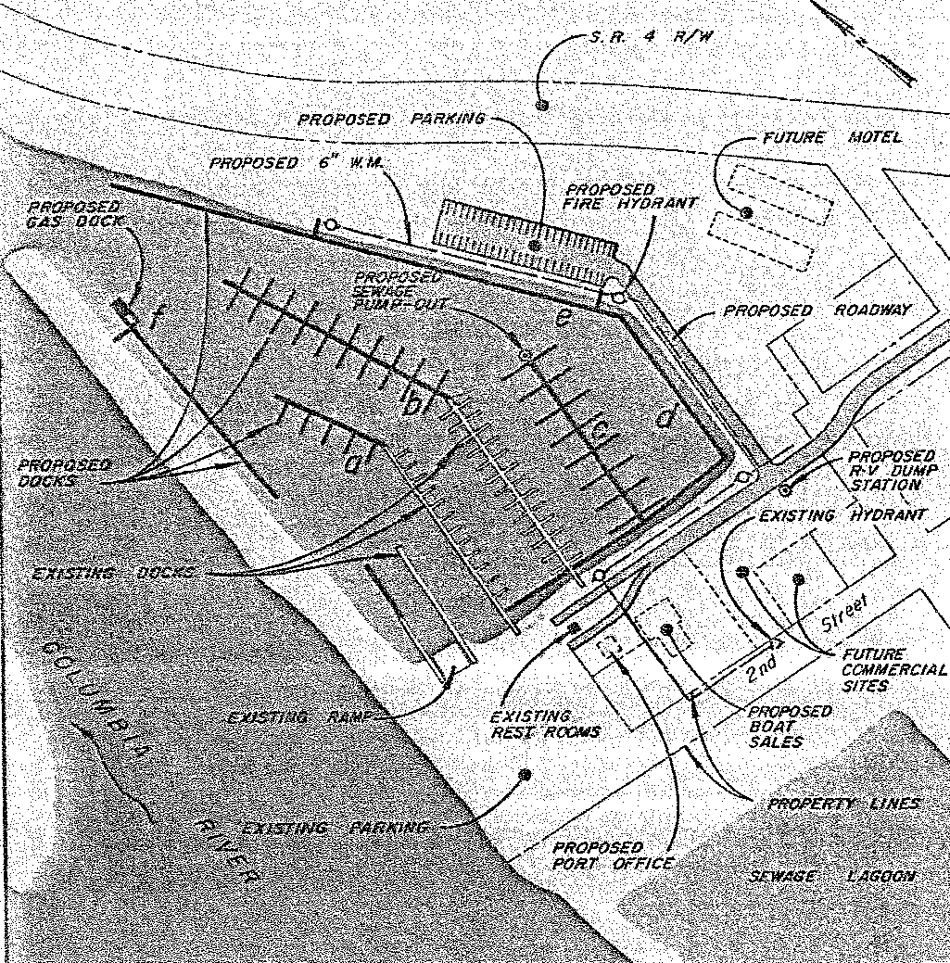

Source: Port District No. 1 Wahkiakum County, Washington Comprehensive Development Plan, 1978

1. That the Port of Wahkiakum County negotiate with the City of Cathlamet for the extension of Third Avenue between Una Avenue and Beal Avenue.
2. That the Port of Wahkiakum County investigate possible financial alternatives for the project and initiate construction at the earliest possible date.
3. That the Port of Wahkiakum County obtain options for the purchase of the Chinook Packing Company property previously mentioned along Second Avenue.
4. That the development of Port owned property adjacent to the marina basis be initiated in accordance with the proposed plan at the earliest possible date.

At this time there was a growing body of evidence that recreational boaters needed more opportunities to find safe harbor between Astoria and Longview. The Elochoman Slough Marina slips were in high demand throughout the summer months. There was strong justification for construction additional piers and docks.

Between 1978 and 1994, Port 1 made most of the improvements identified in the 1978 Comprehensive Scheme. The number of slips was increased from 75 to 140 and the fuel dock was completed. Road improvements were made to improve circulation through the marina area, parking was added, and boat and trailer storage provided for during these years.

Still, the demand for slips and transient moorage continued to grow. The Elochoman Slough Marina was sought out by yachting clubs from Astoria to Portland. During summer weekends, up to 300 boats were accommodated in the marina and the facilities were stretched to the maximum. The Port Commissioners recognized the need to update the Comprehensive Scheme again in 1994.

## 1994 Comprehensive Scheme

In 1994, Benkendorf Associates assisted Port 1 to revise and expand its Comprehensive Scheme. The broad goals of the 1994 Comprehensive Scheme responded to the following isssues:

* High demand for moorage and limited capacity for expansion,
* Development of the vacant and under-utilized upland properties,
* Long-term economic development goals, and
* General marina improvements.

At this time, Port 1 owned approximately 25 acres of land surrounding the Elochoman Slough Marina. This property included the entire area between the marina and the Cathlamet Sewerage Lagoons, the dike which separates the slough from the marina, and all but approximately 1 acre of the embankment to the northeast of the marina from Third Street to the Rock Pit. All the property under Port 1 ownership is with the Town of Cathlamet and is zoned Commercial/Industrial. This zoning provides a high degree of flexibility in the types of uses allowed.

The 1994 Comprehensive Scheme identified the Port 1 mission as follows:

***The Port of Wahkiakum is dedicated to the enhancement, diversification, and stabilization of the local economy as a means of improving the standard of living, business climate, and quality of services available to the citizens of Wahkiakum County.***

In 1994 Port 1 adopted broad goals and objectives that would guide the development of specific projects in the future. These goals and objectives include:

**Industrial Development Goal:** Encourage industrial development in Wahkiakum County. The objective is to develop a:

* Joint venture regional promotion and economic development with other agencies and private business.

**Recreation and Tourism Goals**:

1. Promote and encourage recreational and tourist opportunities within Cathlamet. The objective for this goal are:

* Develop additional recreational opportunities along the Cathlamet waterfront. The policy for implementing this objective is:
  + **Policy**: Acquire property upstream of the present port area for enhanced public waterfront access.
* Encourage and promote tourism on a regional basis. Work closely with other local agencies and private enterprises to attract recreation and tourist business.
* Develop a promotional package and contact operators to locate a new motel on Port Waterfront property. Simultaneously, seek a restaurant operator to locate adjacent to or in conjunction with a motel.
* Investigate financing opportunities and the economic feasibility of the Port’s development of commercial buildings on Port waterfront property, adjacent to the marina.

**Architectural Character of the Port and Cathlamet Goal**:

1. All new commercial development proposed along the marina waterfront shall be in keeping with the older local architectural vernacular. The objective for this goal is:

* Maintain small town architectural character of Cathlamet through new development. The policies for achieving this objective are:
  + **Policy**: New building shall be of similar architectural character and detailing as the existing residence on Port property near the Port office, with natural cedar shake siding and pitched roof line with metal earth-toned roofing material.
  + **Policy**: New development shall be designed to provide pedestrian friendly environment.

**Marina Goals**:

1. Increase the availability of marina moorage in the Cathlamet area

* Explore the opportunity for more marina moorage capabilities outside the Elochoman Slough Marina. The policies for carrying out this objective include:
  + **Policy**: Study marina feasibility on the Elochoman Slough at the current Rock Pit site.
  + **Policy**: Study marina feasibility on the Elochoman Slough adjacent to the port area.
  + **Policy**: Study marina feasibility and look for opportunities to develop upstream of the current Rock Pit site.
* Redevelop the existing marina to more efficiently supply moorage capabilities over time.

1. Continue to supply a high standard of marina-related services.
2. Promote the expansion of recreational boating on the Columbia River in the general area of Cathlamet.

**Marketing and Community Relations Goal**: Broaden local and regional marketing efforts and increased local tourism.

Exhibit 13, which follows, shows the conceptual design for achieving the 1994 goals and objectives:

**Exhibit 13: 1994 Plan for Port 1 Expansion**

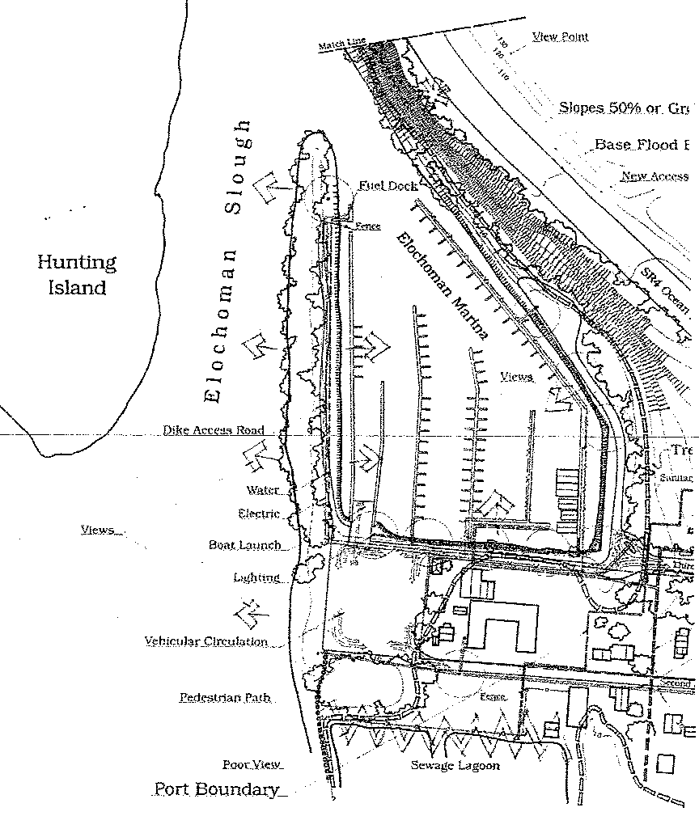

Source: Comprehensive Development Scheme for the Port of Wahkiakum County No. 1, October 1994

## 2006 Comprehensive Scheme

In 2006, Port 1 adopted a Comprehensive Development Scheme prepared by Benbrook and Associates, LLC. The mission of Port 1 was changed slightly, but it maintains the Port’s focus on economic development and quality of life:

***Port District Number 1 of Wahkiakum County is dedicated to the enhancement and diversification of the local economy as a means of improving the standard of living, business climate, and quality of services available to the citizens of and visitors to Wahkiakum County.***

The goals of the 2006 scheme continued and further developed the goals and objectives developed in the 1994 scheme, including the following:

Goal: Maintain and expand a first class marina facility that attracts visitors and boaters to the Port and the community.

Objectives:

* Utilize the existing Port property to continue serving the needs of the marina.
* Maintain, upgrade and expand marina facilities using state-of-the-art materials that minimize environmental impacts while improving the safety of Port for its residents, visitors, and boaters.
* Retain the architectural vernacular of the Port and the surrounding Town of Cathlamet in new buildings, landscaping, and other physical features of the Elochoman Slough Marina.
* Continue to work cooperatively with county and town organizations that promote tourism in Wahkiakum County.

Goal: Improve the marine and boater experience by maintaining and expanding public access to the Columbia River for the local and visiting public.

Objectives:

* Continue to identify and provide improved parking for visitors and boaters with trailers using the marina.
* Evaluate the feasibility of developing a new fishing pier and increase moorage for visitors to the marina.
* Work with the Town of Cathlamet Downtown Revitalization effort.

Goal: Expand economic activity in Wahkiakum County and the region by investing in land and infrastructure that will attract new wealth and employment to the community.

Objectives:

* Seek appropriate opportunities to acquire lands that can be developed for use as industrial, office, retail and economic development sites.
* In collaboration with federal, state and local partners, install the necessary infrastructure, including but not limited to, power, water, wastewater and roads, on Port owned properties.
* Actively engage with appropriate state and local partners in business recruitment, seeking investment in light industry, office and retail businesses and economic activities that are clean and environmentally responsible.
* Provide continuing property management for industrial, office and retail properties that will meet the needs of businesses and organizations leasing Port lands and retain those businesses for the long-term.

Goal: Ensure that Port 1 investments in marketing and community-relations activities support the achievement of Port 1 goals

Objectives:

* Invest in community organizations and activities that promote tourism and economic growth in the community.
* Participate as members of organizations that conduct activities that impact the Port and its activities.

Rationales for these goals and objectives were added to the 2006 scheme for clarification.

## Conditions in 2016

Since 2006, the Port has continued to repair, upgrade and replace docks and moorage facilities according to the comprehensive plan. The Port also completed upgrades to the electrical service in the Marina Office and has continued to install new marina signage.

In spite of increasing the number of slips from 140 to 230, there has remained high demand for moorage in the marina, which continues to the present. There is a waiting list for permanent moorage and summer weekends result in such high demand for moorage that boats are regularly turned away.

The Town of Cathlamet constructed a new wastewater treatment facility on property located North of State Route 4, away from the land between Port 1 property and downtown Cathlamet. The prior sewerage lagoons have been closed and planning is currently underway regarding development of the area. Potential plans include a public park. The Town and the Port have entered into an agreement whereby the Port will be able to deposit dredge spoils onto the lagoon property, and the entities are working together to develop a plan for the area that will benefit the residents of and visitors to Wahkiakum County.

In 2014, the Port leased a portion of its property to a local group of investors and assisted in the construction of a building that now houses a brewery. The brewery recently celebrated its two-year anniversary and has seen its business grow in a way that has allowed it to hire employees and to distribute its product inside and outside of Wahkiakum County. It is a major draw for residents and visitors and has helped surrounding businesses grow as well.

The Port purchased a dredge which will allow it to conduct a maintenance dredging program for the Elochoman Slough marina. Plans for its upgrade and use are currently underway and the Port continues to work with the consulting firm of Maul Foster Alongi to obtain the necessary permits for dredging and material disposal. The Port will research and make necessary purchases of support equipment in order to operate the dredge.

These developments and the need to continue the goals set by the 2006 scheme have led Port 1 to initiate another update and to refine its Comprehensive Scheme.

# Appendix B: Summary of Public Input

**Public Input**

A hearing for public input on the revision and updating of the Comprehensive Scheme was scheduled for the ____________ Port Commission meeting. A notice of said public hearing appeared in the Wahkiakum Eagle newspaper.

1. **Comprehensive Plan Guidelines for Washington’s Public Ports.** A Report by the Cooperative Development Committee, December 1994. Washington Public Ports Association.